**Baseline-performance Modulation Analysis**

In the eventual scenario in which a drug has a performance-enhancing influence for some subjects but a detrimental influence for others, its effects may remain undetected by conventional statistical tests, leading to the wrong conclusion that the drug is innocuous. Such a scenario is plausible given that previous studies on cognitive-enhancing drugs, which took baseline performance into consideration, showed positive effects on attention or impulsivity in low-performing subjects but no effects or detrimental effects in high performers (e.g., Caballero-Puntiverio et al., 2019; Finke et al., 2010; Turner & Burne, 2016; Turner et al., 2017). Therefore, upon the recommendation of an anonymous reviewer, we conducted a formal analysis to test the hypothesis that baseline performance modulates drug effects.

If we are interested in the modulation of phase effects specifically by drug administration, the analysis requires controlling for the regression to the mean that would be observed otherwise (i.e., in the vehicle group). To achieve that, we built a mixed linear model assessing the triple interaction between phase, group, and baseline performance. In mixed linear model nomenclature, its written as dependent_variable ~ phase * group * avg_bl_dependent_variable + (1 | subject).

**Results**

We found that baseline performance invariably modulates phase effects negatively, and it did so significantly for all but two metrics when pooling across groups, that is, regardless of drug treatment (i.e., simple baseline × administration phase interaction; see Table S5, left column). This means that high baseline performers did worse than expected in the drug phase, while low baseline performers did better. However, when including the vehicle control with the drug treatment groups in the analysis, this effect can be explained by regression to the mean.

**Table S5**

*Baseline-Performance Modulation Analysis With and Without Controlling for Regression to the Mean*

|  |  |  |  |
| --- | --- | --- | --- |
|  | Phase * Baseline | Phase * Baseline * MPH | Phase * Baseline * MOD |
| Obtained rewards | ***β = -0.52***  ***CI = -0.72–-0.33 \*\*\**** | *β* = 0.15  CI = -0.15– 0.46 | *β* = 0.31  CI = -0.02–0.65 |
| Efficiency | ***β = -0.39***  ***CI = -0.6–-0.19 \*\*\**** | *β* = -0.02  CI = -0.36–0.32 | *β* = 0.20  CI = -0.08–0.48 |
| Burst responding | ***β = -0.19***  ***CI = -0.34–-0.03 \**** | *β* = 0.10  CI = -0.23–0.43 | *β* = 0.04  CI = -0.17–0.26 |
| Early inhibitory deficit | ***β = -0.40***  ***CI = -0.67–-0.14 \*\**** | *β* = -0.16  CI = -0.55–0.23 | ***β = 0.44***  ***CI = 0.12–0.77 \*\*\**** |
| Timing peak | ***β = -0.74***  ***CI = -1.01–-0.48 \*\*\**** | *β* = 0.20  CI = -0.25–0-65 | ***β = 0.56***  ***CI = 0.10–1.01 \**** |
| Timing spread | *β* = -0.28  CI = -0.62–0.06 | *β* = 0.06  -0.36–0.48 | *β* = -0.39  CI = -0.82–0.05 |
| Attentional lapses | *β* = -0.32  CI = -0.66–0.02 | *β* = 0.24  CI = -0.16–0.63 | *β* = 0.16  CI = -0.47–0.79 |

*Note*. Standardized *β*-values are shown. The sign of the interactions is color-coded (green = positive; red = negative). Statistically significant results are highlighted in bold italics. Significance robustness code: “***”: *p* < 0.001; “**”: *p* < 0.01; “*”: *p* < 0.05.

We found only two significant instances of phase effect modulation by baseline performance when controlling for regression to the mean (i.e., baseline performance modulation for the vehicle group). These modulatory interactions were identified in the timing peak and the early inhibitory index for the Modafinil group (see Table S5, right column). Interestingly, the effect was positive rather than negative, as expected by the low-performers-do-well-with-smart-pills hypothesis. Such a positive performance-drug interaction could be interpreted as revealing some degree of resilience in high performers and/or vulnerability in low performers. As illustrated in Figure S4, subjects from the Vehicle group with a relatively high inhibitory deficit during the Baseline phase exhibited robust negative changes from the Baseline to the Drug phase. Conversely, subjects from the Vehicle group with low early inhibitory index values in the Baseline phase tended to exhibit positive or slightly negative changes in this index from the Baseline to the Drug phase, consistent with the regression-to-the-mean effect. For subjects in the Modafinil group, this tendency was not observed. Notably, the second-to-worst subject during the Baseline phase exhibited a strong positive change in early inhibitory deficit, instantiating a vulnerability in low-performing subjects and resulting in a slightly positive slope for the regression line. It is also worth noting that the subject with the highest inhibitory deficit during the Baseline phase showed only a meager improvement in this index upon modafinil administration; however, given the regression line in the Vehicle group, the expected improvement for this subject was appreciably greater.

**Figure S4**

*Baseline Performance Modulation of Early Inhibitory Deficit by Modafinil*

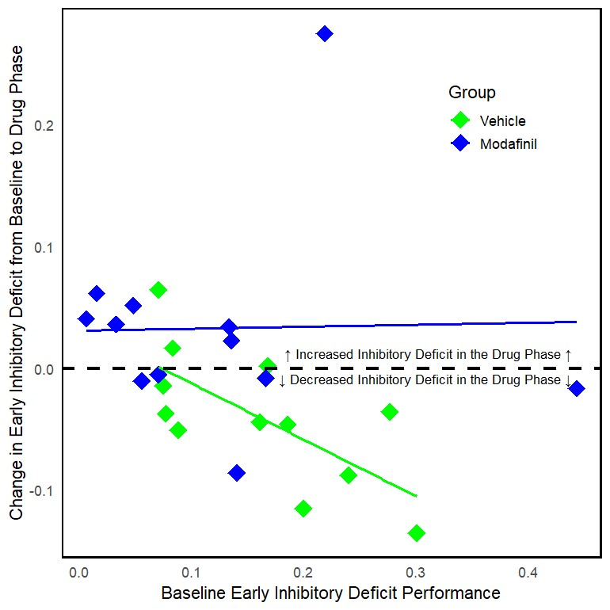

*Note*. The change score was calculated by subtracting each subject's average score in the Baseline phase from their average score in the Drug phase. Diamonds represent values for each individual in the Vehicle (green) and Modafinil (blue) groups, showing baseline performance and the direction of change in early inhibitory deficit. The lines represent the corresponding regression trends. Refer to the Supplementary Materials folder for details on reproducing this analysis.

The absence of any significant modulation in the Methylphenidate group indicates that the lack of acute effects of this drug on behavioral performance, as per the global statistical tests, was not due to opposing effects canceling out in subsets of subjects grouped by baseline performance. In other words, there were no systematically differential effects dependent on baseline performance for this drug (see Table S5, middle column). The apparent resilience/vulnerability phenomenon observed in subjects treated with modafinil is intriguing and merits further investigation.

**References**

Caballero-Puntiverio, M., Lerdrup, L. S., Grupe, M., Larsen, C. W., Dietz, A. G., & Andreasen, J. T. (2019). Effect of ADHD medication in male C57BL/6J mice performing the rodent Continuous Performance Test. *Psychopharmacology, 236*, 1839-1851. <https://doi.org/10.1007/s00213-019-5167-x>

Finke, K., Dodds, C. M., Bublak, P., Regenthal, R., Baumann, F., Manly, T., & Müller, U. (2010). Effects of modafinil and methylphenidate on visual attention capacity: a TVA-based study. *Psychopharmacology, 210*, 317-329. <https://doi.org/10.1007/s00213-010-1823-x>

Turner, K. M., & Burne, T. H. (2016). Improvement of attention with amphetamine in low-and high-performing rats. *Psychopharmacology, 233*, 3383-3394. <https://doi.org/10.1007/s00213-016-4376-9>

Turner, K. M., Peak, J., & Burne, T. H. (2017). Baseline-dependent effects of amphetamine on attention are associated with striatal dopamine metabolism. *Scientific Reports, 7*(1), 297. <https://doi.org/10.1038/s41598-017-00437-9>